Having trouble getting it to recognize the right files for some reason. The directory seems correct though?

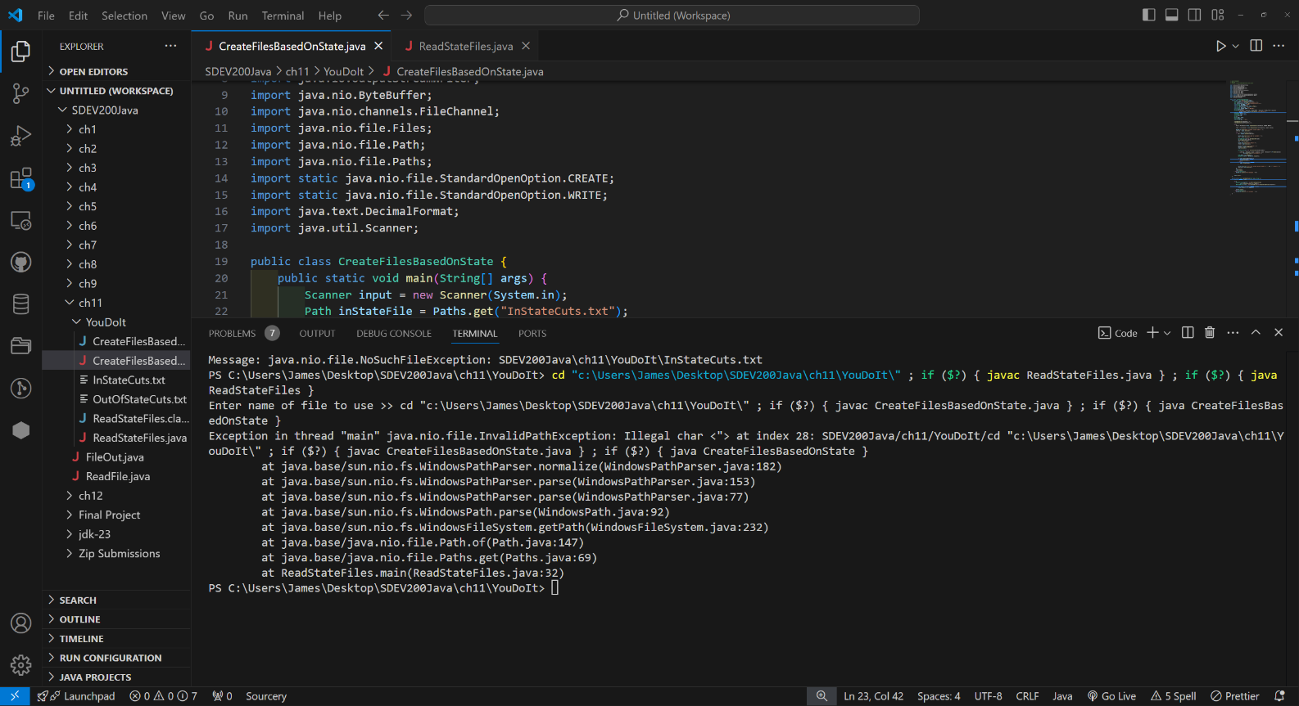

This is throwing errors because the original read file is not working properly.

